Report
Hangman Game

https://github.com/alkafri/fabulous-stars-hangman

Prepared by: Ahmad AlKafri, 2022-12-23

Customer vision: Christoffer “The Client” wants to develop a revolutionary Hangman game, which allows multiple players to play and compete against each other.

Reflection:
Story 1:
- As developer I need to compare between input letters and hidden word.
- Developer Ben & Ahmad
- Method compares between letter from player and hidden word as a list and return result.
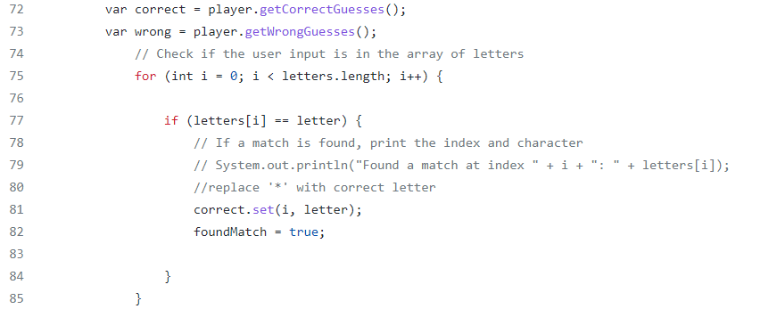

Story 2:
- As developer I need to create a hangman draw on wrong guesses.
- Developer Julius
- Using different images, the game will show one of these images according to the current number of wrong guesses.
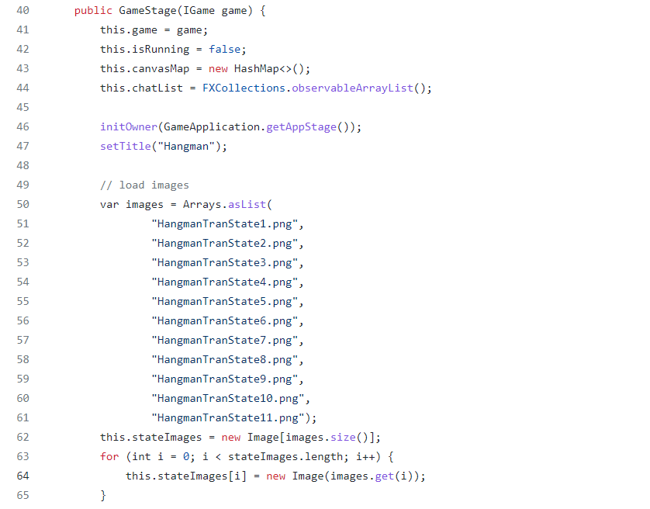

Story 3:
- As developer I need to get the user input for a hidden word.
- Developer Manjurekha
- This method takes the user input from a text box.
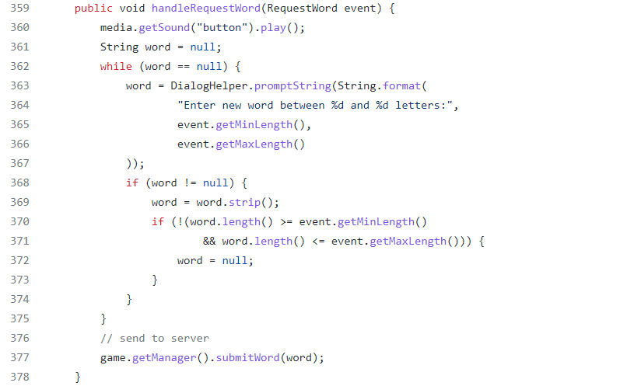
Closure:
We met almost every day to discuss the project. We agreed on the game structure, we decided the part for each one, we choose the challenging parts for each one, I was responsible on working on the game logic part alongside other team members.

Code review was about improving the code. Example:
- Ben to Ahmad: Comments need to be more detailed.
- Ahmad to Julius: Converting hidden word to list, to easily find correct position.

Work with agile probably was challenging, because of lack of work experience, I believe we need more practicing to be able to work according to agile probably.

We used “Kanban” as we used “Trello” to create tasks board and cards, not sufficiently, but more practicing will help to improve.

